Chapter 19, Problem 69.

The circuit in Fig.19.116 may be regarded as two two-ports connected in parallel. Obtain the y parameters as functions of s.

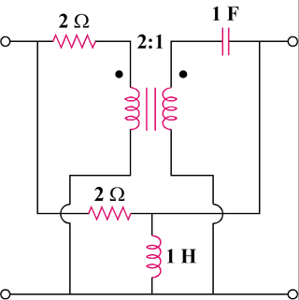

Figure 19.116
For Prob. 19.69.

